Ajanta Barua
April 14, 2011
Professor Henry Miller
American Civilizations

Ancient Unknown Beings and Objects

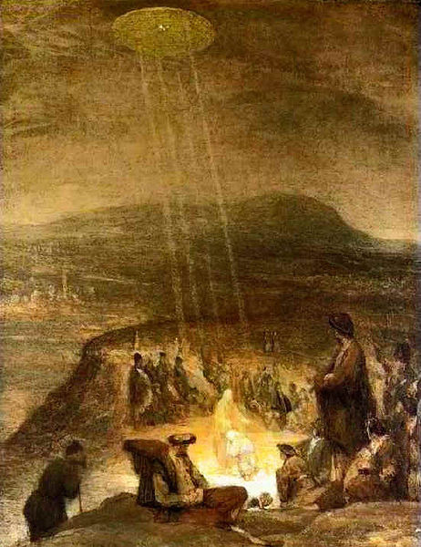
For many years, Unidentified Flying Objects and extraterrestrials have been sighted and unexplained. Scientists and different researchers have provided some explanations for these sightings in ancient and in present times. Some sightings have been waved off with explanations of weather balloons and others as airplanes or military aircraft. What many people don’t know or haven’t noticed is that UFOs and extraterrestrials have been sighted all over the world in ancient times throughout different types of art and documents. There are many biblical art pieces that include UFO’s and detailed descriptions in Sanskrit documents. “The Baptism of Christ" by Flemish artist Aert De Gelder, is a painting that is nothing unusual at a first glance but with a closer look, you can see that the light in the painting isn’t just coming from an opening. You can observe that there are places of shading and highlighting from that “opening” to where you can actually make out a disc shape. This painting is widely known throughout most UFO websites.
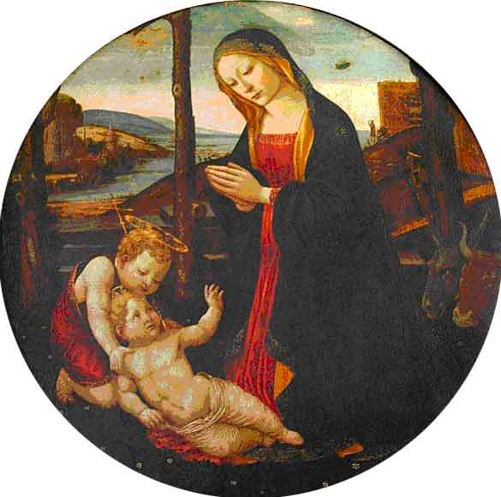
In the "Madonna col Bambino e San Giovannino", there is an object on the right of the Virgin Mary. Some have said that it is a “cloud of light” although most clouds aren’t painted with a straight line of gold in the middle. Most “clouds of light” are painted with many curvy lines to make it look “fluffy”.
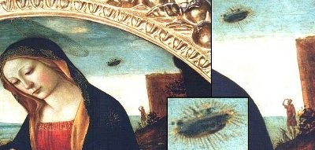One famous explorer, during one of his expeditions, sighted a light resembling light from a wax candle that moved up and down. He also noted that there were other witnesses. That individual was Christopher Columbus; here is an excerpt from his journal:
“After sunset steered their original course west and sailed twelve miles an hour till two hours after midnight, going ninety miles, which are twenty-two leagues and a half; and as the Pinta was the swiftest sailer, and kept ahead of the Admiral, she discovered land and made the signals which had been ordered. The land was first seen by a sailor called Rodrigo de Triana, although the Admiral at ten o'clock that evening standing on the quarter-deck saw a light, but so small a body that he could not affirm it to be land; calling to Pero Gutierrez, groom of the King's wardrobe, he told him he saw a light, and bid him look that way, which he did and saw it; he did the same to Rodrigo Sanchez of Segovia, whom the King and Queen had sent with the squadron as comptroller, but he was unable to see it from his situation. The Admiral again perceived it once or twice, appearing like the light of a wax candle moving up and down, which some thought an indication of land. But the Admiral held it for certain that land was near; for which reason, after they had said the Salve which the seamen are accustomed to repeat and chant after their fashion, the Admiral directed them to keep a strict watch upon the forecastle and look out diligently for land, and to him who should first discover it he promised a silken jacket, besides the reward which the King and Queen had offered, which was an annuity of ten thousand maravedis.”
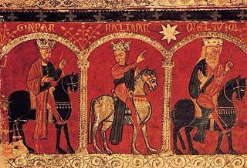
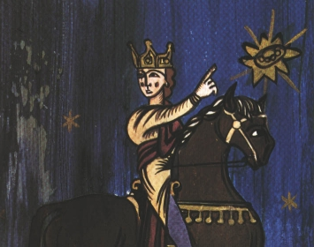
There also have been some famous pictures spreading out among a vast majority of UFO-in-art websites but upon a closer look, it looks really skeptical. This picture of a man (looks like a king) is one that is commonly seen in these websites. The captions usually refer to this picture originating from the book “Annales Regni Francorum”. You can see the rough texture behind the paint, from my experience, looks like watercolor paper used in modern day or a cheap “canvas”. The outlining in the picture also looks too bold and vivid and brilliant to be dated back from the 8th century. Another thought is that the picture wouldn’t be in such good condition, there’s no sign of aging. With more research, I found a painting that was done in the 13th century, it illustrates the three magi, one pointing to the star of Bethlehem and is titled, “Frontal d'altar de Mosoll”. The man from the first picture looks like a copy of the King from the second picture and the UFO in the first picture look likes they just pasted a UFO ontop of the star of Bethelem. Even though I can safely presume that this picture is a modern fake, the event of spotting a strange object in the sky during the 8th century is actually recorded in the “Annales Regni Francorum”:
“[776] … But the power of God, just as it is just, he overcame their power, and on a certain day, in a war against the Christians preparations in advance, that is in him the castle sat down, he clearly appeared to the glory of God upon house of the church, which is below him, and the castle, the sight of many, as well, and also outwardly and even within , of whom many remain until this present; and they say, like he had seen of the two with a red, fiery color of shields and the church itself and driving the above. And when they had seen this sign, the pagans, who were also outwardly, at once they were confounded and dismayed, they began to with great fear to flee to the camp, and all the multitude of them for a flight undertaken struck with fear, others, from the one which he had killed some one from another. For he that behind him on account of fear some looked, infigebant himself with the spears of those who have gone before them and did they flee on their shoulders and carried it, the blows, and other diverse are to one another and have suffered, condemned in the divine vengeance. And as much as the power of God upon them because of the salvation wrought by the Christians, no one can be to tell and yet his fear to him more as much as they were being terrified, the more they have strengthened the Christian God they praised the Almighty, who has deemed it to make known his power over his servants.] And from thence, put to flight, laying hold of the Saxons, they still pursued them are the French, killing the them up to the river, BE BLEAR-EYED, the castle of your Saviour, and when they returned to the victory of the French.”
The most intriguing painting to me so far is "The Crucifixion" painted in 1350 by Visoki in Decani Monestary located in Kosovo, Yugoslavi. It illustrates two people, each in a flying object. It looks as though one is chasing after another. It is also said that the two can be representing the Sun and the Moon. Other pictures illustrate faces, or not humanized objects. One painting illustrated the sun and moon riding on a wagon pulled by horses. Others are not humanized and look like little flying saucers. The left object in “The Crucifixion” is colored with a slight tint of red and the right has stars to show that they do in fact represent the sun and moon. The bottom picture is actually another painting in the same Decani Monastery, located in a lower vault. In this painting, the sun and moon look like angels. I found “The Crucifixion” interesting because even though the shape around the two beings resemble the shapes on the bottom picture, I haven’t seen other paintings where they look like as if they are riding in a flying unidentifiable object.
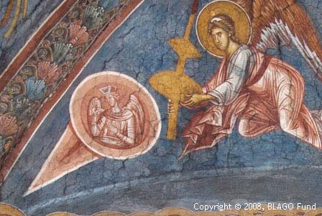
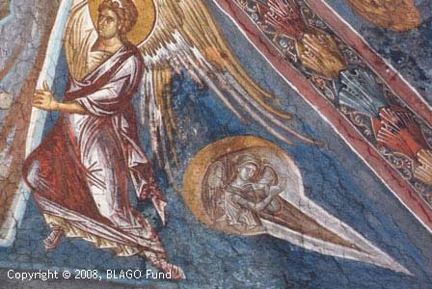
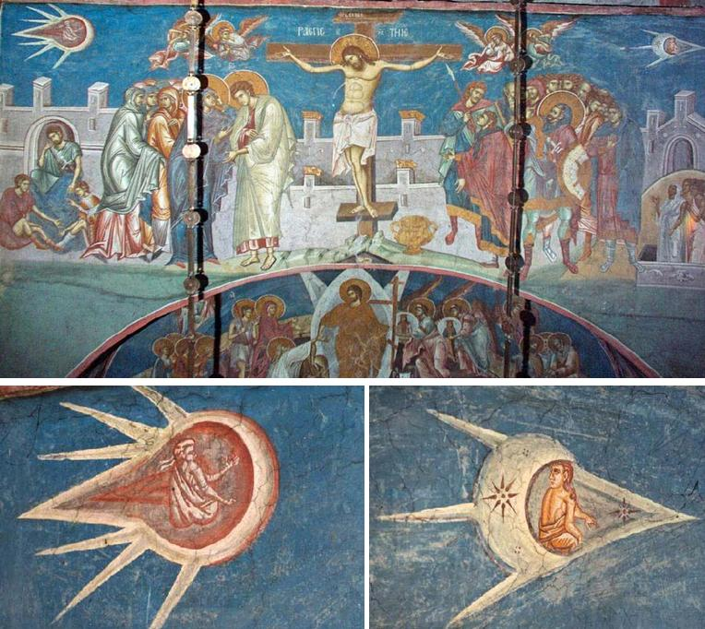
In Asia, the Vedic and Puranic Sanskrit documents has a section called the “Samarangana Sutradhara”, it describes a flying machine in detail:
“Strong and durable must the yantra's body be made, of light material and having wings joined smoothly with invisible seams. It can carry passengers, it can be made small and compact, it can move in silence. If sound is to be used successfully, there must be great flexibility in the driving mechanism, and all must be put together flawlessly. In order for it to accomplish its intended purpose, it must be extremely durable, it must be well covered in . . . it must not become too hot, too stiff, nor too soft, and its sharp-pointed battering ram must also be indestructable. Indeed, the machine's main qualities, which are remembered by one and all, include unending motion—which is to say perpetual motion. Smoothness is one of the machines supreme qualities; thus, the workings of the machine must be versatile, complete, not given to expansion, never complaining, and always applicable to the task.”
"At the critical time the beam of fire must be released, which will make the action possible. The time-beam expands, accompanied by the thunder of the expanding medium. This resultant expansion performs work like an elephant in an endless cycle."
“The manufacturing of a conquering yantra is greatly to be desired . . . using light-weight wood to build a great air-going machine of a strong-bodied type. In the central container is the liquid consumed by the engine, which gradually burns away during complete combustion."
” "Fully renown are the techniques for mastering the following motions: vertical ascent; vertical descent; forwards; backwards; normal ascent; normal descent; slanting; progressing over long distances through proper adjustment of the working parts . . . its air-rending sound and roaring thunder can easily drown out the trumpeting of an elephant in panic—but it can also be moved by musical tones.
"Shining in every direction, their machine (yantra) could travel wherever the imagination dictated. From their great height they saw stimulating dances, drama plays, and pristine ritualistic ceremonies. Their yantra gained renown among Royal dynasties and various nations. In such a manner the High-Souled ones flew, while the lower classes walked. All those friends succeeded in their much-deserved acquisition of a yantra, by means of which human beings can fly in the air, and non-earthling, Celestial Beings, can come down to mortals when visiting the Earth."
". . . Thus, inside one must place the Mercury-engine; and properly mounted beneath it, the iron heating apparatus. Men thusly set the dual-winged, driving whirlwind in motion; and the concealed pilot, by means of the mercury-power, may travel a great distance in the sky."
“An extremely swift and nimble vimana can be built, as large as the temple of the God-in-motion. Into the interior structure four strong mercury containers must be installed. When these have been heated by a controlled fire from iron containers, the flying machine develops thunder-power through the mercury, becoming a highly desirable yantra. Moreover, if this iron engine with properly welded joints be filled with fluid [mercury?], when ascending or descending over land it generates power with the roar of a lion.
"The machine's construction and operating details are not publicly disclosed. For if their motivative power be made known publicly to others—giving out results described elsewhere—elements of these machines could be wrongly used."
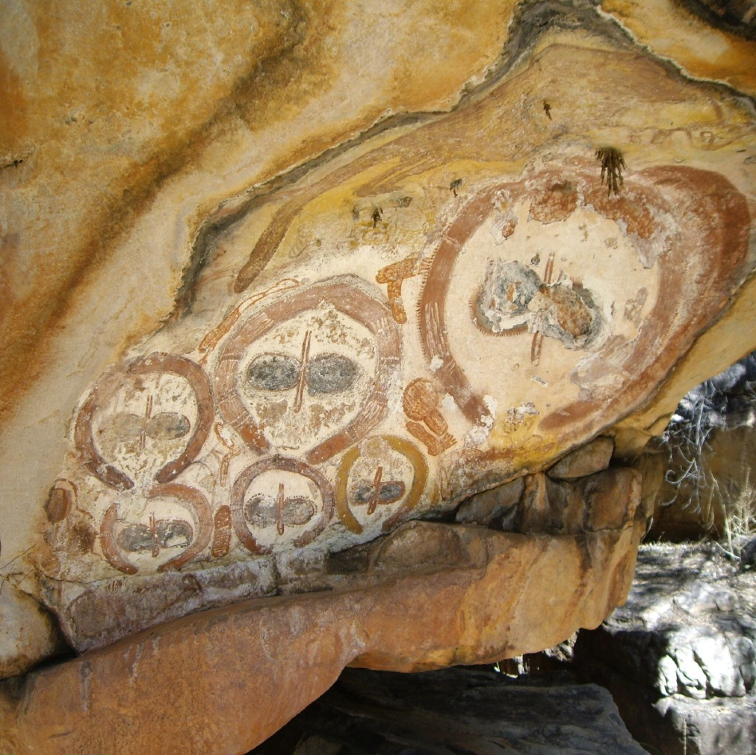
This excerpt from Sanskrit from Vedic and Puranic Sanskrit documents are in great detail. Many archaeologists say that most Sanskrit documents are purely myth although some current findings can somewhat prove otherwise, like the discovery of the ancient city of Deváraká. There is no way to disprove the Sanskrit documents as myth and many wonder how India, as early as 4,000 BC, are able to make up such detailed crafts from imagination. Most people cannot write purely from imagination and thus, end up basing writings or art off of an event or object they have seen or heard about. We will probably never know if the Sanskrit documents were completely fictional nor truth.
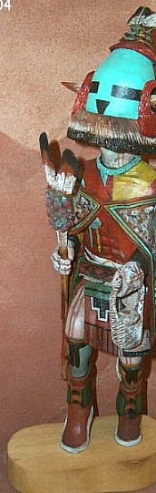
The Wandjina drawings, located in Australia, are fascinating. This cave drawing resembles what most people today call, “Grey” aliens. The “Greys” are the most common depiction of extraterrestrials. They are usually illustrated with an extremely bloated head, large black eyes, skinny fingers, are 3 feet tall, no nose (just nostrils holes) and no lips (just the mouth opening). The Wandjina style drawings represent mythical beings that are associated with the creation of the world. So far, the Kimberley region of Australia, is the only place that these figures are found.

In Southwestern United States, there are many different types of Native American tribes. The most famous among them are the Navajo, Hopi, Apache, and the Anasazis. In the Hopi culture, there are stories about how different gods from above come down and bless them with good crops or seasons. Many people think that their “Kachina” gods resemble aliens or ancient astronauts, like the one on the left.

No matter where and when in the world, there are stories of beings and objects that come from the sky. Objects in the sky and beings from above have been recorded and drawn from, which almost seems like, the beginning of time. There are many things that scientists have yet to explain. We live in a vast universe, one of many, and Earth being the only populated planet, seems more unbelievable than these “extraterrestrials”.
Works Cited
“Ancient UFO's Represented in Paintings.” Blue Knight Productions. 2001-2008. Web. 14 April 2011. <http://www.thelivingmoon.com/49ufo_files/03files2/UFOs_in_Art_01.html>

“Annales Regni Francorum”. The Latin Library. Web. 14 April 2011. <http://www.thelatinlibrary.com/annalesregnifrancorum.html>

Cuoghi, Diego. “Part 2”. Art and UFOs?. 23 November 2002. Web. 14 April 2011. <http://www.sprezzatura.it/Arte/Arte_UFO_2_eng.htm>

“Frontal d'altar de Mosoll”. Museu Nacional a’Art de Catalunya. 2009. Web. 14 April 2011. <http://art.mnac.cat/fitxatecnica.html;jsessionid=647215f4ee6e6067af14ad4edcb14044dd3f2e68e62da67cf67540ea20fdbfc5?inventoryNumber=015788-000>

Halsall, Paul. “Christopher Columbus: Extracts from Journal”. Medieval Sourcebook. Mar 1996. Web. 14 April 2011. <http://www.fordham.edu/halsall/source/columbus1.html>

Leonard, Cedric R. “An Ancient Airplane”. Atlantis Quest. 23 November 2010. Web. 14 April 2011. <http://www.atlantisquest.com/Samar.html>

“Sanskrit documents”. Sanskrit Documents.org. Web. 14 April 2011. <http://sanskritdocuments.org/doc_purana/doc_purana.html>

"Wandjina Style." Encyclopædia Britannica. Encyclopædia Britannica Online. Encyclopædia Britannica, 2011. Web. 12 Apr. 2011. <http://www.britannica.com/EBchecked/topic/635290/wandjina-style>.
“About Us”. Kachina Spirit World. 2007. Web. 14 April 2011. <http://www.kachinaspiritworld.com/aboutus.htm>.
“History”. Navajo Nation Government. 2011. Web. 14 April 2011. < http://www.navajo.org/history.htm>.
“Hopi: The Real Thing”. Four Corners Clamor. 2000. Web. 14 April 2011. < http://www.ausbcomp.com/redman/hopi.htm>.
“Apache Tribal Nation”. Great Dreams. Web. 14 April 2011. < http://www.greatdreams.com/apache/apache-tribe.htm>.
“Anasazi”. Utah History to Go. 2010. Web. 14 April 2011. < http://historytogo.utah.gov/utah_chapters/american_indians/anasazi.html>.

Painted in 1710 and is now located at Fitzwilliam Museum, Cambridge, England.
(Madonna and Child with the Infant Saint John), attributed to Sebastiano Mainardi or Jacopo del Sellaio now located at Firenze, Palazzo Vecchio Museum, Sala d'Ercole.
Journal of Christopher Columbus, entry from October 11, Thursday.
Annals covering the history of early Carolingian monarchs from 741 to 829 and is written by Einhard.
Romanesque Art painted by an anonymous 13th century Catalan artist. The three Magi is a small section from a larger altar painted wooden piece with stucco reliefs and can be seen on display in Barcelona in the Museu Nacional d'Art de Catalunya.
Vedic Sanskrit - language of the Vedas, texts compiled over the period of early-to-mid 2nd to mid 1st millennium BCE.
Puranic Sanskrit - a genre of important Hindu, Jain and Buddhist religious texts.
Samarangana Sutradhara ("Battlefield Commander") Translated from the Sanskrit, By R. Cedric Leonard
Deváraká - is the homeland of a famous Hindu god named Krishna that has been recently found under the sea, located where the Mahabharata tells of.
Wandjina - prehistoric inhabitants of the Kimberley region in northwest Australia
Greys – are aliens that are usually associated with big black eyes, no noses (just nostrils), and no lips. They are usually depicted with extremely large heads, skinny fingers, and are around 3 feet tall.
Soutwestern United States – pertaining to Arizona, New Mexico, Colorado, and Utah.
Navajo – one of the largest Native Nations in Native American culture, extends into the states of Utah , Arizona and New Mexico , covering over 27,000 square miles
Hopi - lived in the Four Corners area for at least 1,000 years
Apache - occupied the mountains and plains of southern Arizona and New Mexico, and in Mexico
Anasazi - thought to be ancestors of the modern Pueblo Indians, inhabited the Four Corners country of southern Utah, southwestern Colorado, northwestern New Mexico, and northern Arizona from about A.D. 200 to A.D. 1300. Their name means “Ancient Ones” and means “enemy ancestors” in Navajo.
Kachina – the Hopi Tribe’s “gods”

